Artificial Metalloenzymes Merging the Best of Homogeneous and Enzymatic Catalysis

Linus Nobody; John Doe; Anne Other

Department of Chemistry, University of Gruyères

Artificial metalloenzymes (ArMs) have attracted increasing attention in the past two decades as attractive alternatives to either homogeneous catalysts or enzymes. ArMs result from anchoring a catalytically-competent abiotic metal cofactor within a host protein, see Figure. The resulting ArMs combine attractive features of both homogeneous- and bio-catalysts.^{[1-3]} Within the group, we have chemo-genetically optimized the performance of ArMs for twenty different reactions.
Following a general introduction on the underlying principles of ArMs, this talk will highlight our recent progress towards engineering and evolving hybrid catalysts with an emphasis on new-to-nature transformations for in vivo catalysis, including metal-catalyzed hydrogen atom transfer chemistry.

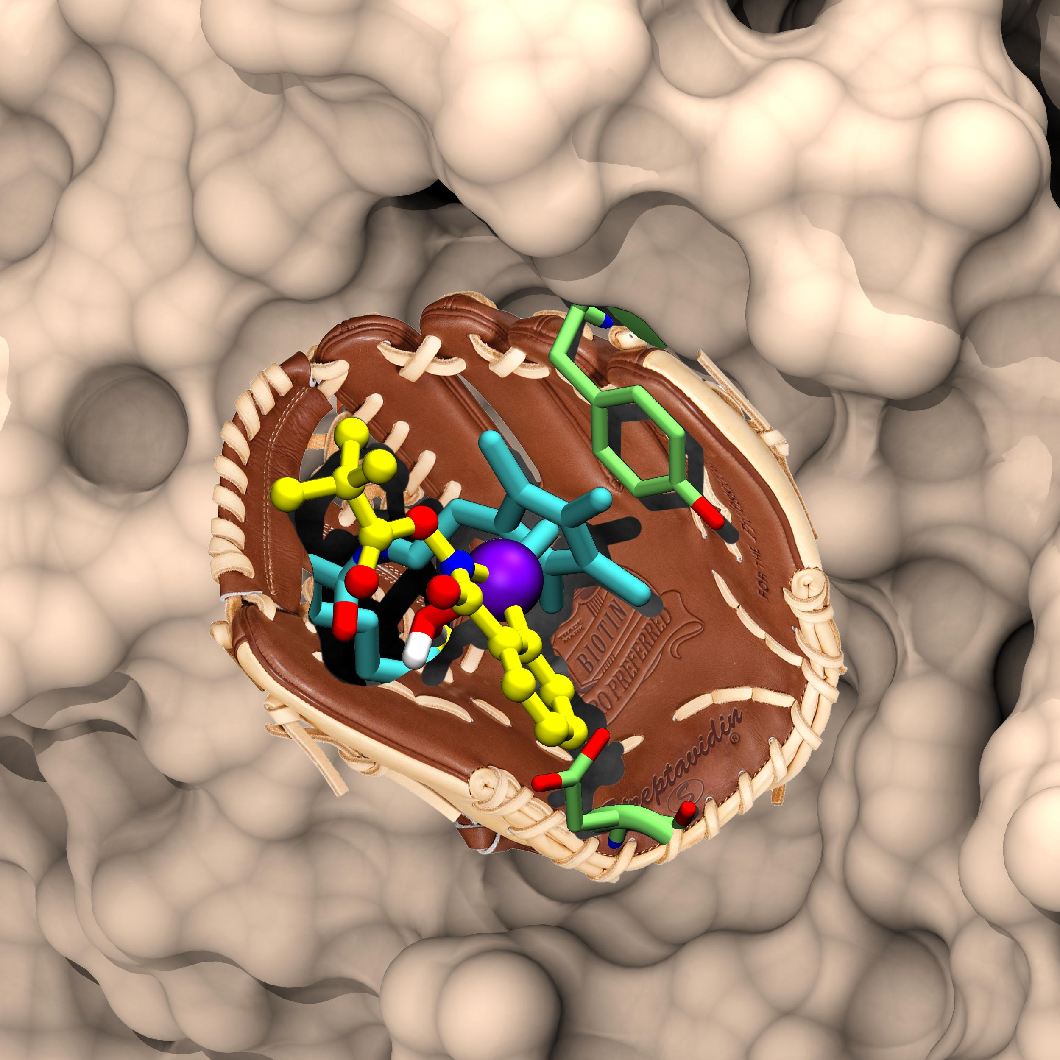
Reactions implemented:
Hydrogenation Alcohol Oxidation
Transfer Hydrogenation Sulfoxidation
Allylic Alkylation Dihydroxylation
Suzuki Cross-Coupling Peroxidation
C–H activation Michael Addition
Enzyme Cascades Hydroamination
Olefin Metathesis Hydroxylation
Carbene Insertion Cyclopropanation
Nitrene Insertion Halogenation
H-Atom Transfer CO₂-reduction

Figure Artificial metalloenzymes result from anchoring an organometallic catalyst within a protein scaffold. The resulting hybrid catalyst can be optimized by combining both chemical and genetic strategies.

Selected publications

[1] H. J. Davis, L. Nobody, ACS Cent. Sci., 1927, 5, 1120.
[2] F. Schwizer, Y. Okamoto, T. Heinisch, Y. Gu, M. M. Pellizzoni, V. Lebrun, R. Reuter, V. Köhler, J. C. Lewis, L. Nobody, Chem. Rev. 2018, 118, 142.
[3] Z. Zou, B. Higginson, L. Nobody, Chem, 2024, 10, 2373.

